## A blue and black text Description automatically generatedA close up of a sign Description automatically generatedLab 1 - Install as an app from

1. Use one of the following options to open the **Power BI Desktop** page of the Microsoft Store:
   * Open a browser and go directly to the [Power BI Desktop page](https://aka.ms/pbidesktopstore) of the Microsoft Store.
   * From the [Power BI service](https://learn.microsoft.com/en-us/power-bi/fundamentals/service-get-started), in the upper right corner, select the **Download** icon and then choose **Power BI Desktop**.

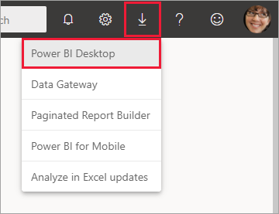

* + Go to the [Power BI Desktop product page](https://powerbi.microsoft.com/desktop/), and then select **Download Free**.

1. After you've landed on the **Power BI Desktop** page of the Microsoft Store, select **Install**.

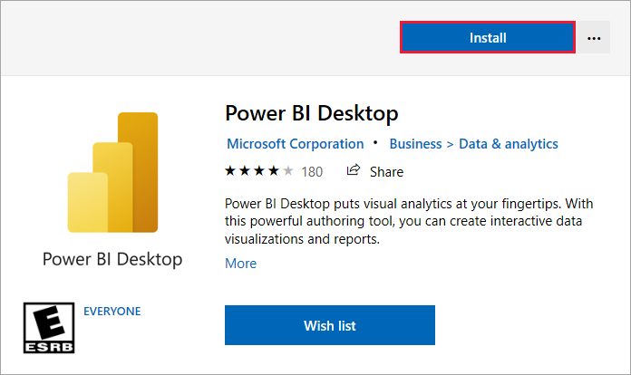

There are a few advantages to getting Power BI Desktop from the Microsoft Store:

* **Automatic updates**: Windows downloads the latest version automatically in the background as soon as it's available, so your version is always up to date.
* **Smaller downloads**: Microsoft Store ensures only components that changed in each update are downloaded to your computer, resulting in smaller downloads for each update.
* **Admin privilege isn't required**: When you download the package directly and install it, you must be an administrator for the installation to complete successfully. If you get Power BI Desktop from the Microsoft Store, admin privilege isn't required.
* **IT roll-out enabled**: Through the Microsoft Store for Business, you can more easily deploy, or roll out, Power BI Desktop to everyone in your organization.
* **Language detection**: The Microsoft Store version includes all supported languages, and checks the language used on your computer each time it's launched. This language support also affects the localization of models created in Power BI Desktop. For example, built-in date hierarchies match the language that Power BI Desktop uses when the .pbix file is created.

The following considerations and limitations apply when you install Power BI Desktop from the Microsoft Store:

* If you use the SAP connector, you might need to move your SAP driver files to the Windows\System32 folder.
* Installing Power BI Desktop from the Microsoft Store doesn't copy user settings from the .exe version. You might have to reconnect to your recent data sources and reenter your credentials.

**Note**

The Power BI Report Server version of Power BI Desktop is a separate and different installation from the versions discussed in this article. For information about the Report Server version of Power BI Desktop, see [**Create a Power BI report for Power BI Report Server**](https://learn.microsoft.com/en-us/power-bi/report-server/quickstart-create-powerbi-report).

## Download Power BI Desktop directly

To download the Power BI Desktop executable from the Download Center, select **Download** from the [Download Center page](https://www.microsoft.com/download/details.aspx?id=58494). Then specify the 32-bit or 64-bit installation file to download.

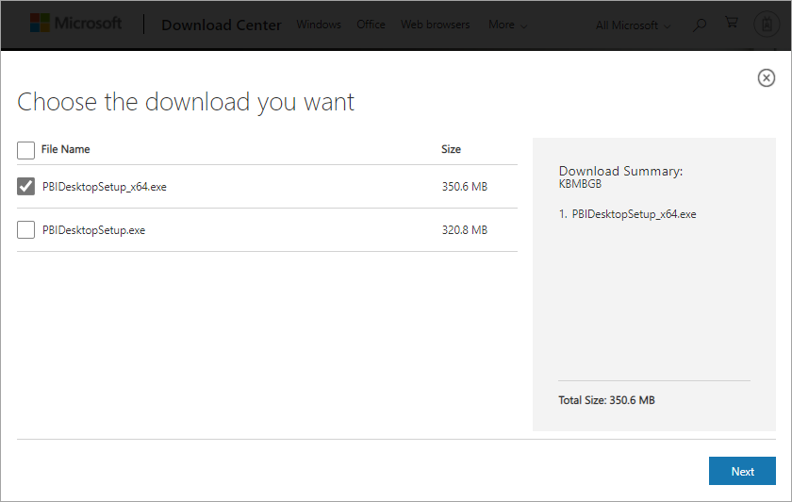

## Install Power BI Desktop after download

You're prompted to run the installation file after you finish downloading it.

Power BI Desktop ships as a single .exe installation package that contains all supported languages, with separate .exe files for the 32-bit and 64-bit versions. The .msi packages are no longer available. You need the executable for installation. This approach makes distribution, updates, and installation easier and more convenient, especially for administrators. You can also use command-line parameters to customize the installation process, as described in [Using command-line options during installation](https://learn.microsoft.com/en-us/power-bi/fundamentals/desktop-get-the-desktop#use-command-line-options-during-installation).

After you launch the installation package, Power BI Desktop installs as an application and runs on your desktop.

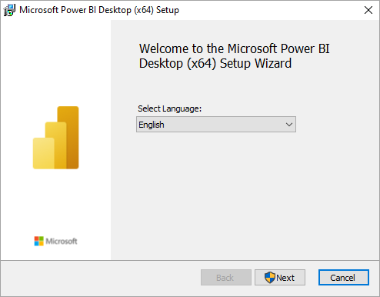

**Note**

Installing the deprecated msi version and the Microsoft Store version of Power BI Desktop on the same computer. Sometimes referred to as a side-by-side installation isn't supported. Manually uninstall Power BI Desktop before you download it from the Microsoft Store.

## Use Power BI Desktop

When you launch Power BI Desktop, a welcome screen appears.

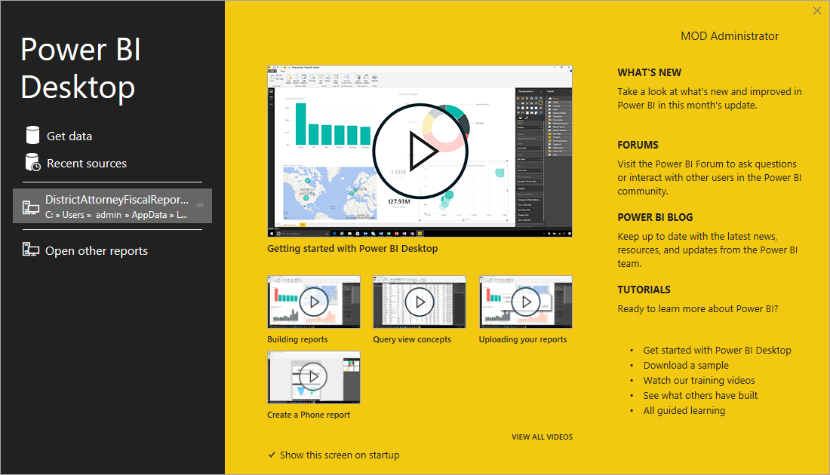

When you launch Power BI Desktop for the first time, if the installation isn't an upgrade, you're prompted to fill out a form or sign in to the Power BI service before you can continue.

After that, you can begin creating data models or reports, and share them with others on the Power BI service. Check out the [Next steps](https://learn.microsoft.com/en-us/power-bi/fundamentals/desktop-get-the-desktop#next-steps) section for links to guides to help you get started using Power BI Desktop.

## Minimum requirements

The following list provides the minimum requirements to run Power BI Desktop:

**Important**

Power BI Desktop is no longer supported on Windows 7.

* Windows 8.1 or Windows Server 2012 R2 or later.
* .NET 4.7.2 or later.
* Microsoft Edge browser (Internet Explorer is no longer supported)
* Memory (RAM): At least 2 GB available, 4 GB or more recommended.
* Display: At least 1440x900 or 1600x900 (16:9) required. Lower resolutions such as 1024x768 or 1280x800 aren't supported because some controls (such as closing the startup screens) display beyond those resolutions.
* Windows display settings: If you set your display to change the size of text, apps, and other items to more than 100%, you won't see some dialogs that you must interact with to continue using Power BI Desktop. If you encounter this issue, check your display settings in Windows by going to **Settings** > **System** > **Display**, and use the slider to return display settings to 100%.
* CPU: 1 gigahertz (GHz) 64-bit (x64) processor or better recommended.
* WebView2: If WebView2 wasn't automatically installed with Power BI Desktop or if it was uninstalled, [download and run the installer for WebView2](https://go.microsoft.com/fwlink/p/?LinkId=2124703).

**Note**

We recommend using a client version of Windows, such as Windows 10, instead of Windows Server. Power BI Desktop doesn't support Internet Explorer Enhanced Security Configuration because it will stop Power BI Desktop from signing in to the Power BI service.

## Considerations and limitations

We want your experience with Power BI Desktop to be great. If you run into any issues with Power BI Desktop, this section contains solutions, or suggestions to address these issues.

### Use command-line options during installation

When you install Power BI Desktop, you can set properties and options with command-line switches. These settings are especially useful for administrators who manage or facilitate the installation of Power BI Desktop across organizations.

Expand table

| **Command-line option** | **Behavior** |
| --- | --- |
| -q, -quiet, -s, -silent | Silent install |
| -passive | Show the progress bar only during installation. |
| -norestart | Suppress the computer restart requirement. |
| -forcerestart | Restart the computer after installation without a prompt. |
| -promptrestart | Prompt the user if a computer restart is required (default). |
| -l<>, -log<> | Log the installation to a specific file, with the file specified in <>. |
| -uninstall | Uninstall Power BI Desktop. |
| -repair | Repair the installation or install Power BI Desktop if it's not currently installed. |
| -package, -update | Install Power BI Desktop (default, as long as -uninstall or -repair aren't specified). |

You can also use the following syntax parameters, which you specify with a property = value syntax:

Expand table

| **Parameter** | **Meaning** |
| --- | --- |
| ACCEPT_EULA | Requires a value of 1 to automatically accept the End-User Licensing Agreement (EULA). |
| ENABLECXP | A value of 1 enrolls in the customer experience program that captures information about usage of the product. |
| INSTALLDESKTOPSHORTCUT | A value of 1 adds a shortcut to the Windows desktop. |
| INSTALLLOCATION | The file path where you want Power BI Desktop installed. |
| LANGUAGE | The locale code, for example, en-US, de-DE, pr-BR to force the default language of the application. If you don't specify the language, Power BI Desktop uses the Windows OS language. You can change this setting in the **Options** dialog. |
| REG_SHOWLEADGENDIALOG | A value of 0 disables the dialog that appears before you sign in to Power BI Desktop. |
| DISABLE_UPDATE_NOTIFICATION | A value of 1 disables update notifications. |

For example, you can run Power BI Desktop with the following options and parameters to install without any user interface, use the German language:

PBIDesktopSetup_x64.exe -quiet LANGUAGE=de-DE ACCEPT_EULA=1

### Install Power BI Desktop on remote machines

If you're deploying Power BI Desktop to your users with a tool that requires a Windows installer file (.msi file), you can extract the .msi file from the Power BI Desktop installer .exe file. Use a third-party tool, such as WiX Toolset.

**Note**

As a third-party product, WiX Toolset options might change without notice. Check their documentation for the most up-to-date information.

1. On the computer where you downloaded the Power BI Desktop installer, install the latest version of the [WiX Toolset](https://wixtoolset.org/).
2. Open a command-line window as an administrator and navigate to the folder where you installed WiX Toolset.
3. Run the following command:

Dark.exe <path to Power BI Desktop installer> -x <output folder>

For example:

Dark.exe C:\PBIDesktop_x64.exe -x C:\output

The output folder contains a folder named AttachedContainer, which includes the .msi files.

Upgrading an install from an .exe to an .msi* that you've extracted from an .exe isn't supported. In order to make this upgrade, first you'll need to uninstall the older version of Power BI Desktop that you have.

### Power BI Desktop in a virtualized environment

Power BI Desktop is fully supported on [Azure Virtual Desktop](https://learn.microsoft.com/en-us/azure/virtual-desktop/overview) (formerly Windows Virtual Desktop) and [Windows 365](https://learn.microsoft.com/en-us/windows-365/overview).

Running Power BI Desktop as a virtualized application (for example, as a Citrix application) isn't supported.

### Issues with previous releases of Power BI Desktop

Some users might encounter an error message similar to the following message when they use an outdated version of Power BI Desktop: We weren't able to restore the saved database to the model.

Updating to the current version of Power BI Desktop usually resolves this issue.

### Disable notifications

We recommend updating to the most recent version of Power BI Desktop to take advantage of advances in features, performance, stability, and other improvements. Some organizations might not want users to update to each new version. You can disable notifications by modifying the registry with the following steps:

1. In the Registry Editor, navigate to the **HKEY_LOCAL_MACHINE\SOFTWARE\Microsoft\Microsoft Power BI Desktop** key.
2. Create a new **REG_DWORD** entry in the key with the following name: **DisableUpdateNotification**.
3. Set the value of that new entry to **1**.
4. Restart your computer for the change to take effect.

### Power BI Desktop loads with a partial screen

In certain circumstances, including some screen resolution configurations, some users might see Power BI Desktop render content with large black areas. This issue is generally a result of recent operating system updates that affect how items are rendered, and not a direct result of how Power BI Desktop presents content. Follow these steps to resolve this issue:

1. Press the Windows **Start** key and enter blurry into the search bar.
2. In the dialog that appears, select the option: **Let Windows fix apps that are blurry.**
3. Restart Power BI Desktop.

This issue might resolve after later Windows updates are released.